Vityarthi project
Topic – entertainment ( Games)

Name of the game dodge the blocks

FROM – Shivam Choubey

Registration number – 25BAI11566

CONTENTS:
- Introduction
- Requirements
- Objective
- Scope
- Methodology
- Expected outcome
- Future enhancement
- Results

INRTODUCTION:
This project involves the design and development of a simple 2D arcade-style game using Python and the pygame library. The game challenges players to control a character that must avoid multiple falling enemies. It serves as an introduction to game development concepts such as event handling, collision detection, scoring systems, and rendering graphics.

Requirements:
- The game window should have fixed dimensions (e.g., 600×400 pixels).
- The player can move left and right using the arrow keys.
- Multiple enemies fall from the top of the screen at varying positions.
- When an enemy reaches the bottom of the screen, it respawns at a random horizontal position above the screen.
- The player earns points for each enemy successfully dodged.
- The game ends immediately if the player collides with any enemy.
- The final score should be displayed when the game ends.
Objectives
- To implement a playable game using Python and pygame.
- To demonstrate fundamental game development concepts:
  - Player movement and control
  - Enemy spawning and movement
  - Collision detection
  - Score tracking and display
- To create an engaging and interactive experience that tests player reflexes.
- To provide a foundation for future enhancements such as sound effects, difficulty scaling, and multiple levels.
Scope
- Inclusions:
  - A single-player game with a fixed screen size.
  - Player movement restricted to left and right directions.
  - Multiple enemies falling from the top of the screen.
  - Score increment when enemies are successfully dodged.
  - Game termination upon collision with any enemy.
- Exclusions:
- Multiplayer functionality.
- Advanced graphics or animations beyond basic shapes.
- Complex physics or AI-driven enemy behavior.
Methodology
- Tools & Technology: Python 3.x, pygame library.
- Design Approach:
- Define player and enemy objects using pygame.Rect.
- Use event handling for player input (arrow keys).
- Implement a game loop to update positions, check collisions, and render graphics.
- Maintain a score counter and display it on the screen.
Expected Outcome
- A functional game where the player controls a blue square and avoids multiple red squares falling from the top of the screen.
- A scoring system that rewards the player for each enemy successfully dodged.
- A clear "Game Over" condition when the player collides with an enemy.
- A fun, interactive project that demonstrates the basics of game programming.
Future Enhancements
- Add varying speeds for enemies to increase difficulty.
- Introduce levels or stages with progressive challenges.
- Include sound effects and background music.
- Replace squares with sprites for a more visually appealing design.
- Add a restart option after game over.

RESULTS:
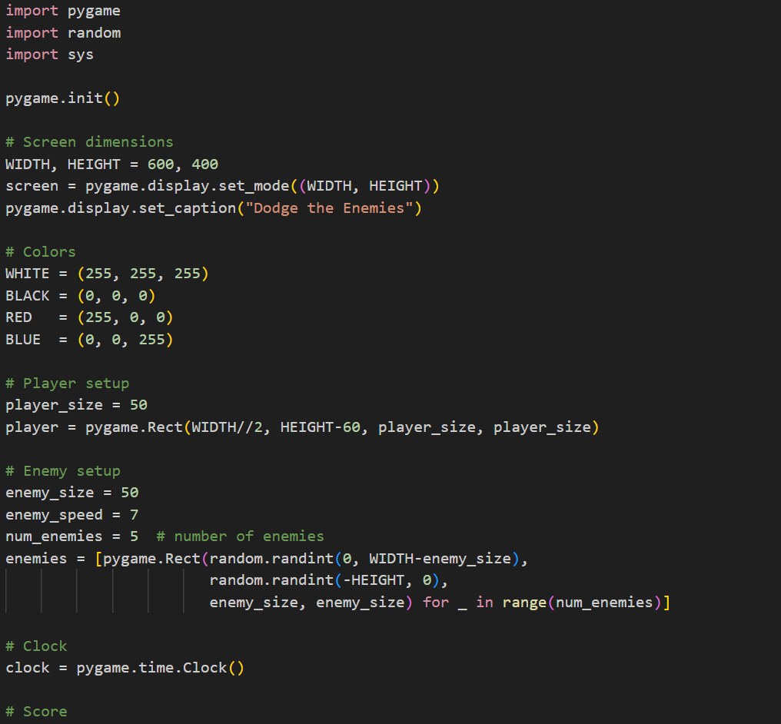

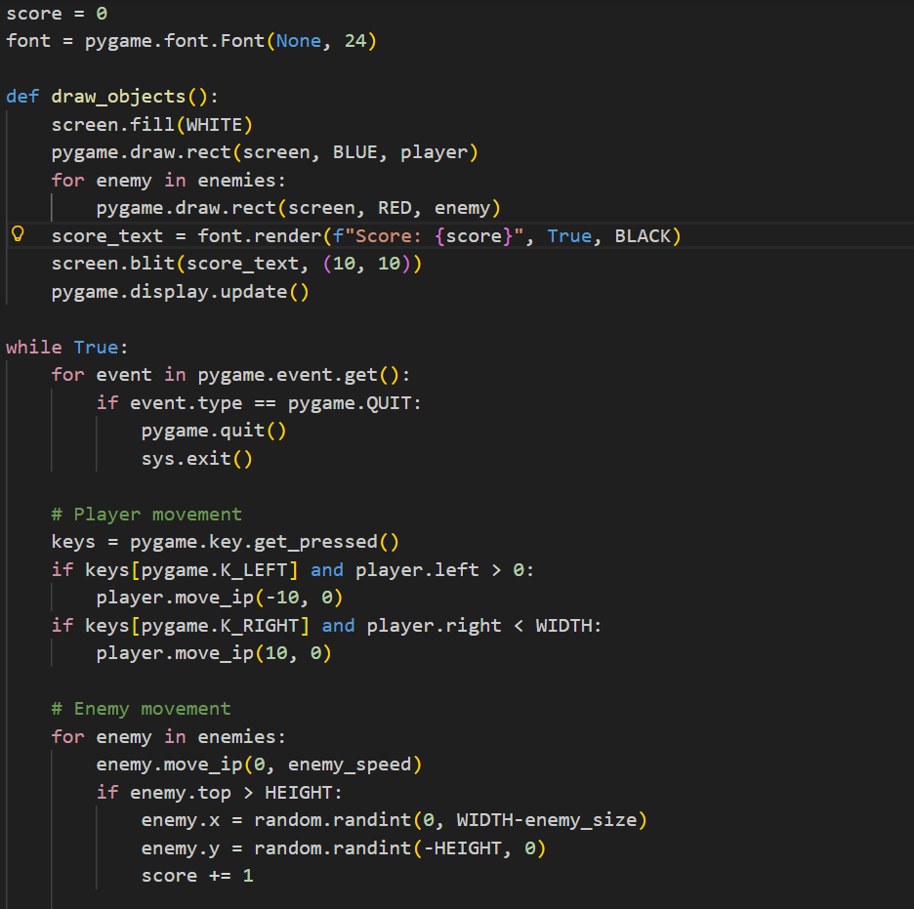

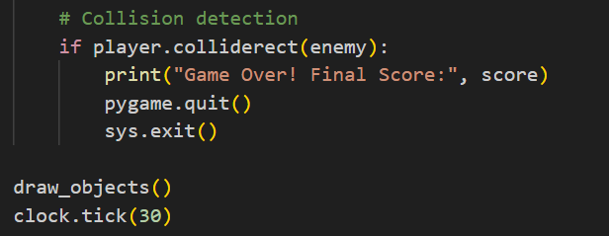
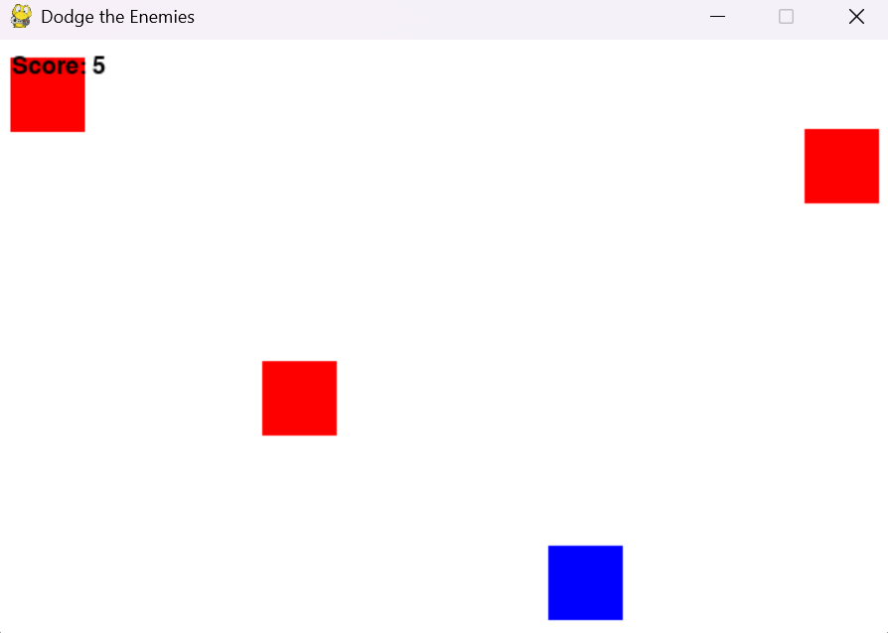

REFERENCES:
Official Pygame Documentation – The primary source for learning about the pygame library, including setup, game loops, event handling, and rendering. You can find it on pygame.org.
- PyGame Tutorial (GeeksforGeeks) – A beginner-friendly tutorial that explains how to build simple 2D games, handle graphics, sounds, and user input. Available at GeeksforGeeks.
- Python Game Development Cheat Sheet – A concise guide covering pygame basics, setup, and game loop essentials. Check it out on Python Cheat Sheet.
- Python Arcade Library Documentation – Another modern Python library for 2D games, useful if you want to compare or extend beyond pygame. See Arcade Docs.
- Create a 2D Game with Python and Arcade (GeeksforGeeks) – A step-by-step tutorial for building games with the Arcade library, offering a clean API alternative to pygame. Available at GeeksforGeeks Arcade Tutorial.
- Arcade Primer (Real Python) – A detailed guide on using the Arcade framework, covering sprites, collision detection, and game loop design. Read it on Real Python.

